**Lab 5: Software Installation and Version Verification on AlmaLinux**

This document contains the screenshots and explanations for the installation and version checking of various software packages on an AlmaLinux server, as per the requirements of Lab 5.

**Apache Version**

**Command Used:**

sudo dnf install httpd -y

httpd -v

**Explanation:**

* The sudo dnf install httpd -y command installs the Apache HTTP server.
* The httpd -v command verifies the installed version of Apache on the server.

**Screenshot Purpose:** This screenshot shows the version of Apache installed on the server, confirming successful installation.

**MariaDB Version**

**Command Used:**

sudo dnf install mariadb-server mariadb -y

mysql --version

**Explanation:**

* The first command installs both the MariaDB server and client.
* The mysql --version command checks the installed version of MariaDB on the server, confirming successful installation.

**Screenshot Purpose:** This screenshot verifies the version of MariaDB installed using the mysql --version command.

**GCC Compiler Version**

**Command Used:**

sudo dnf groupinstall "Development Tools" -y

gcc --version

**Explanation:**

* The groupinstall command installs the necessary development tools, including the GCC compiler.
* The gcc --version command verifies that the GCC compiler is installed by showing the version number.

**Screenshot Purpose:** This screenshot confirms that the development tools, including GCC, were installed successfully and displays the installed version of GCC.

**PHP Version**

**Command Used:**

sudo dnf install php -y

php -v

**Explanation:**

* The sudo dnf install php -y command installs PHP on the server.
* The php -v command checks the installed version of PHP to ensure it was installed correctly.

**Screenshot Purpose:** This screenshot shows the version of PHP installed on the server, obtained using the php -v command.

**Python Version**

**Command Used:**

sudo dnf install python3 -y

python3 --version

**Explanation:**

* The sudo dnf install python3 -y command installs Python 3 on the system.
* The python3 --version command checks the installed version of Python 3.

**Screenshot Purpose:** This screenshot verifies the version of Python 3 installed on the system, confirmed using the python3 --version command.

**Samba Version**

**Command Used:**

sudo dnf install samba -y

smbstatus

**Explanation:**

* The sudo dnf install samba -y command installs the Samba server.
* The smbstatus command checks the current status of the Samba server, including the version information.

**Screenshot Purpose:** This screenshot confirms the installation of the Samba server and displays the version of Samba running on the system.

**Samba Client Version**

**Command Used:**

sudo dnf install samba-client -y

smbclient -V

**Explanation:**

* The sudo dnf install samba-client -y command installs the Samba client.
* The smbclient -V command checks the installed version of the Samba client, ensuring the installation was successful.

**Screenshot Purpose:** This screenshot verifies the version of the Samba client installed on the system, using the smbclient -V command.

**System Updates**

**Command Used:**

sudo dnf check-update

sudo dnf update -y

**Explanation:**

* The sudo dnf check-update command checks for any available updates on the system.
* The sudo dnf update -y command installs all available updates, ensuring the system is up to date.

**Screenshot Purpose:** This screenshot shows the successful completion of system updates, ensuring all packages on the server are up to date.

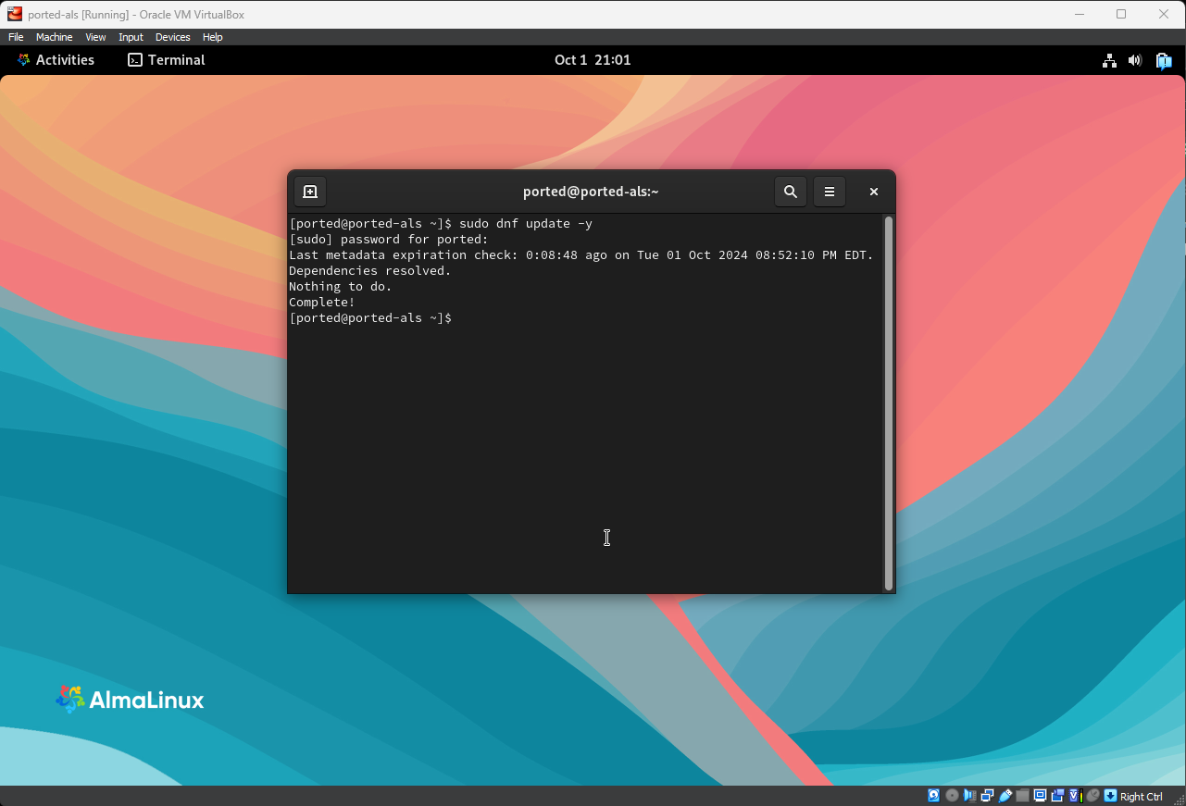

Documentation:

Apache Version

Commands Used:

sudo dnf install httpd -y to install the Apache HTTP server.

httpd -v to check the installed version of Apache.

Explanation: The Apache HTTP server was installed, and its version was verified using the httpd -v command.

Screenshot Purpose: Confirms successful Apache installation and displays the installed version.

MariaDB Version

Commands Used:

sudo dnf install mariadb-server mariadb -y to install MariaDB server and client.

mysql --version to verify the installed version of MariaDB.

Explanation: MariaDB server and client were installed, and the mysql --version command was used to confirm the installed version.

Screenshot Purpose: Verifies successful installation by displaying the MariaDB version.

GCC Compiler Version

Commands Used:

sudo dnf group install "Development Tools" -y to install development tools, including GCC.

gcc --version to check the installed version of GCC.

Explanation: The GCC compiler was installed using a package group installation, and its version was verified with gcc --version.

Screenshot Purpose: Confirms the successful installation of GCC and displays the installed version.

PHP Version

Commands Used:

sudo dnf install php -y to install PHP.

php -v to check the installed version of PHP.

Explanation: PHP was installed, and its version was verified using the php -v command.

Screenshot Purpose: Displays the installed version of PHP to confirm successful installation.

Python Version

Commands Used:

sudo dnf install python3 -y to install Python 3.

python3 --version to verify the installed version of Python.

Explanation: Python 3 was installed, and the version was verified using python3 --version.

Screenshot Purpose: Shows the installed version of Python 3, confirming installation.

Samba Version

Commands Used:

sudo dnf install samba -y to install the Samba server.

smbstatus to check the status and version of Samba.

Explanation: Samba server was installed, and its version was verified using the smbstatus command.

Screenshot Purpose: Confirms that Samba was installed and running by displaying its version.

Samba Client Version

Commands Used:

sudo dnf install samba-client -y to install the Samba client.

smbclient -V to check the installed version of the Samba client.

Explanation: Samba client was installed, and its version was checked using the smbclient -V command.

Screenshot Purpose: Verifies the successful installation of the Samba client and displays its version.

System Updates

Commands Used:

sudo dnf check-update to check for available system updates.

sudo dnf update -y to install all available updates.

Explanation: The system was checked for updates and updated to ensure all packages were up to date.

Screenshot Purpose: Confirms successful completion of system updates by displaying the update process.